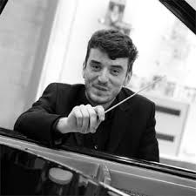

Benjamin Hamilton Translator

As a translator and conductor of opera, Benjamin Hamilton believes in bringing the artform to its audience in as digestible a form as possible - whether that is a traditional literal translation or a trans-adaptation! He trained in translation with the inimitable Kit Hesketh-Harvey (of Kit and the Widow fame) and in conducting under Paul McGrath (English Touring Opera) and Mark Heron (Royal Northern College of Music).

Benjamin has written nine English performance translations (and a trio of surtitles) and aims always to take account of the level of adaptation sought by the producer and director. Of particular note are his trio of translations for Warwick Arts Centre: Carmen, a traditional literal translation; Hansel and Gretel, a resetting of the story to modern Roma-gypsy circus (complete with a circus ringmaster replacing the witch), yet adhering closely to the original text; and a ‘The Only Way is Essex’ trans-adaptation of Rossini’s La Cenerentola complete with Gok Wan fairy-godfather and oodles of fake tan! More recently he has written a “smart, funny and beautiful” translation for the Belgrade Theatre and an “unnervingly realistic” yet “sharp, witty” ‘Oxford’ translation of Don Giovanni for Hampstead Garden Opera, complete with a ‘Tinder-aria’ to update the sentiments of the ever-famous catalogue aria. He looks forward to raising 'The Bat' out of Hackney...

